# Benubird PDF Quick Start Guide–version 1.4.0.9.2

Benubird PDF is a personal document manager for home and business users -- providing an easy way to archive, manage and retrieve your documents. Whilst Benubird can be used with all file types it is optimised for use with PDF files.

## Before you start

A list of known issues for Benubird PDF is available at Start > Programs > Benubird PDF > README

## To install

1. Download the latest version of Benubird PDF from the link below and save it to a folder on your computer.

<http://www.debenu.com/benubird/builds/benubird_pdf_en.exe>

1. Begin the installation process by double-clicking on benubird_pro_en.exe.
2. When the installation process has finished you will be given the option to view the Readme file for Benubird PDF and to launch Benubird PDF.
3. After installation you should have following files in the Program Files\Benubird PDF\ folder or \Program Files (x86)\Benubird PDF\ on your computer:
   1. BenubirdPDF.exe
      1. Main application
   2. BenubirdAssistant.exe
      1. Runs as a process in the background and is used for the watched folders feature. This process runs even when the main Benubird PDF app is closed.
   3. BenubirdShell.dll
      1. Required for Benubird PDF entry in the Windows Explorer contextual-menu.
   4. BenubirdShell64.dll
      1. Required for Benubird PDF entry in the Windows Explorer contextual-menu on 64-bit operating systems.
   5. QuickPDFAX0813.dll
      1. Required for manipulating PDF properties, converting images to PDF and performing PDF previews.
   6. Uninst.exe
      1. File used to uninstall Benubird PDF (note: the recommended way of uninstalling Benubird PDF is through the Control Panel)
   7. novapv.exe
      1. Application file used for installing the PDF printer driver.
   8. Benubird PDF Quick Start Guide.pdf
      1. Quick start guide for Benubird PDF.
   9. Readme.txt
      1. Text file explaining changes and updates to Benubird PDF
   10. Benubird.db
       1. Benubird PDF Library database. Stores information about file properties, file location, collections, tags, watched folders, etc.

**C:\Users\< username>\AppData\Roaming\Benubird** *(Windows Vista/Windows 7)*

**C:\Documents and Settings\< username>\Application Data\Benubird** *(Windows XP)*

## Starting Benubird PDF

1. Double-click on the Desktop or Start Menu shortcuts for Benubird PDF.
2. The first-time that Benubird PDF starts it will take a few seconds while it creates the database that is used to store the Benubird PDF Library.



Figure 1 - Creating/Loading the Benubird PDF Library database

1. You must add at least a few files to get started…

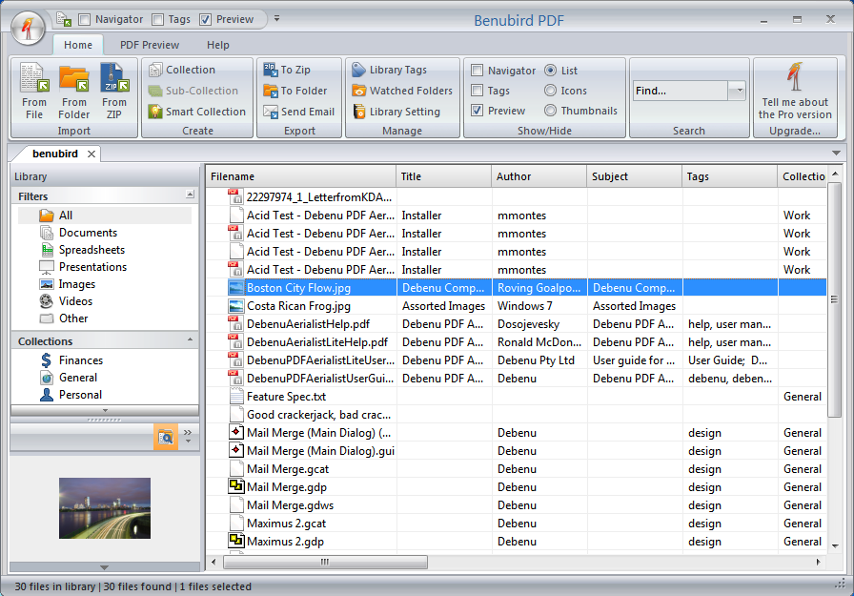

Figure 2 - Benubird PDF Library after initialization

## Adding Files

1. Add a file to Benubird PDF by clicking the Add File button, and then selecting the file(s) you wish to add to the Library.

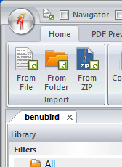

Figure 3 - Add File and Add Folder buttons

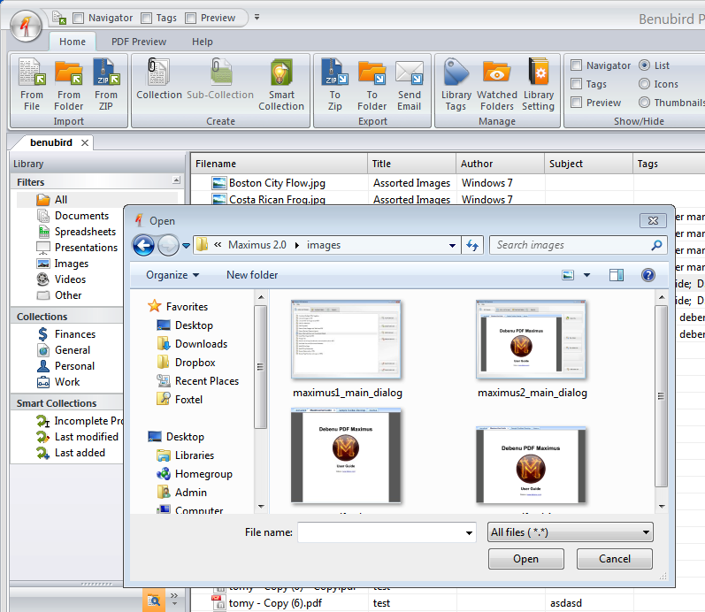

Figure 4 - Add File dialog

1. Add a folder to Benubird PDF by clicking on the Add Folder button then selecting the folder you wish to add.

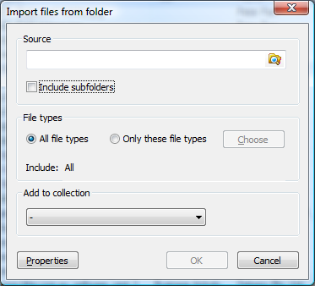

Figure 5 - Add Folder dialog

## Library views

The Library consists of All, Documents, Spreadsheets, Presentations, Images, Videos and Other. These views are at the top of the filtering hierarchy.

* **All** – this is the default view for Benubird PDF. Every file in the Benubird PDF Library is displayed here.
* **Documents**–this filter displays Microsoft Word documents, PDF documents, Text files and OpenOffice Writer documents.
* **Spreadsheets** – this filter displays Microsoft Excel and OpenOffice Cal spreadsheets.
* **Presentations** – this filter displays Microsoft PowerPoint and OpenOffice Impress presentations.
* **Images** – this filter displays JPG, GIF, BMP, TIF and PNG images, plus more.
* **Videos** – AVI files, MPG, mpeg, plus more.
* **Other** – everything else that isn’t included in the other filters. Like executables and so on.

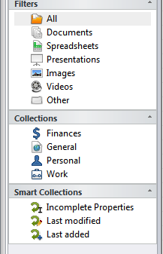

Figure 6 - Library views

## Incomplete Properties

1. After you have added files to Benubird PDF you probably want to view the *Incomplete Properties* collection. This contains a list of all of the files that are missing the sort of info that you need in order to find them quickly. We find it’s best to enter the info straight away otherwise you tend to forget and it becomes a real chore to process later.

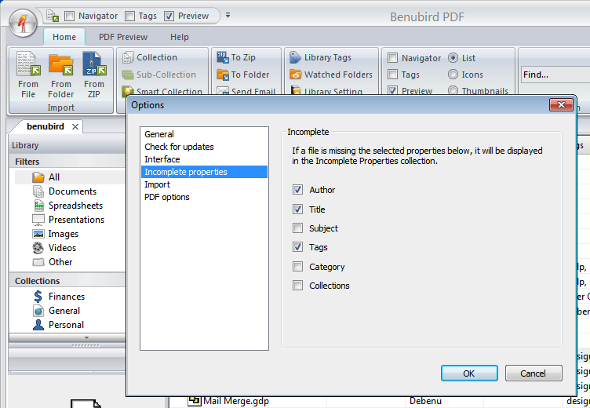

1. You configure (in the options dialog) what properties are required in order to pass the *Incomplete Properties* filter. For example: if you set Title and Author, then all files that do not have a title or author specified will be listed in the *Incomplete Properties* collection.
2. As you complete the fields required, the files will automatically be removed. A well-organised Library won’t have any documents in this filter.

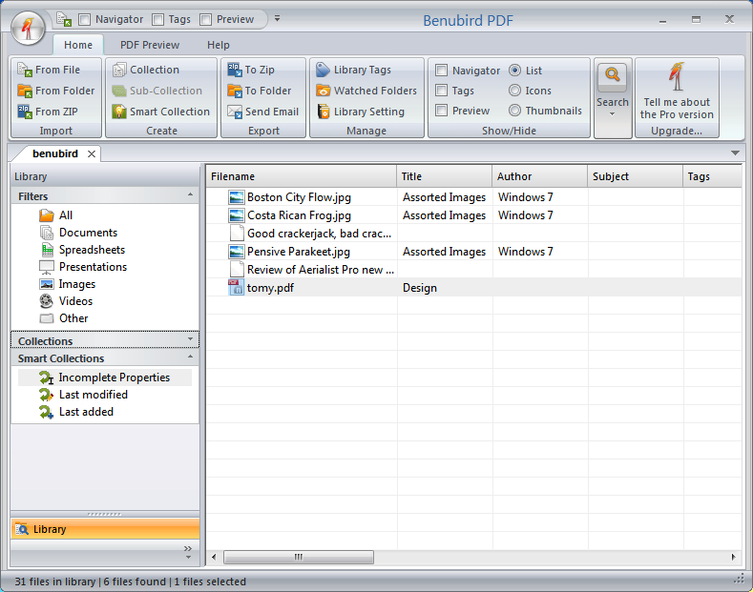

Figure 7 - List of *Incomplete Properties*

1. In order to adjust the properties of a file right-click select ‘Properties from the context menu.

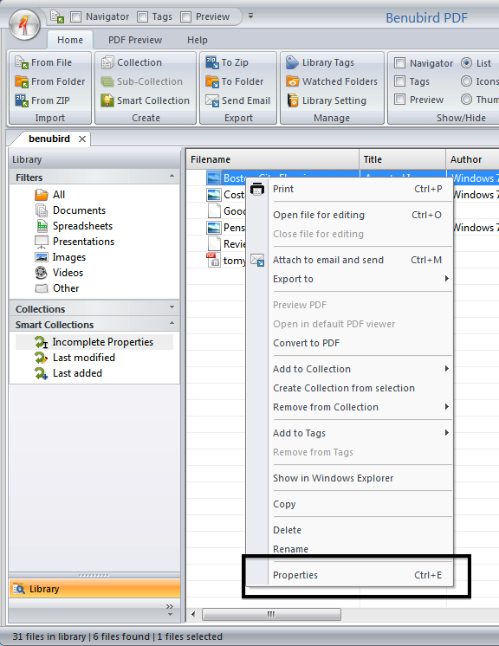

Figure 8 - Right-click context menu

1. Simply fill in the available property fields and click on OK to save the information.

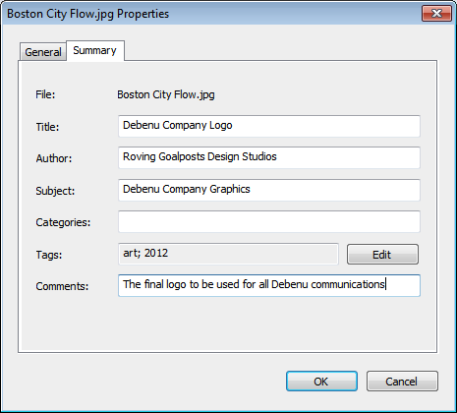

Figure 9 - Edit properties dialog

1. Repeat this process for each of your files that appear in the *Incomplete Properties* filter and files will be dynamically removed after you have updated their properties.

## Collections

A collection is a document equivalent of a ‘playlist’. You can use a collection to create a ‘virtual folder’ of documents to work with. Unlike files and folders in Windows Explorer, one file in Benubird PDF can belong to multiple collections, so there is no danger of creating duplicate files.

1. To create a collection, select the Collections button from the Create panel. An ‘untitled collection’ will be created in the Library list.
2. You can rename collections by double-clicking on the collection name or right clicking on it and selecting Rename from the context menu.

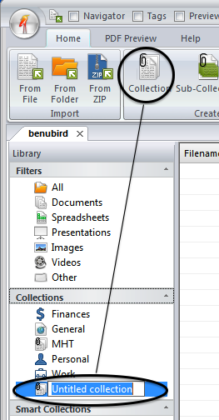

Figure 10 - Create new collection

1. To add files to your new collection go to Library > All and right-click on the file you wish to add select ‘Add to Collection’ from the context menu, then choose which collection you would like the file to be added to.
2. You can add multiple files to a collection by selecting the files while holding down Ctrl and left clicking on them.

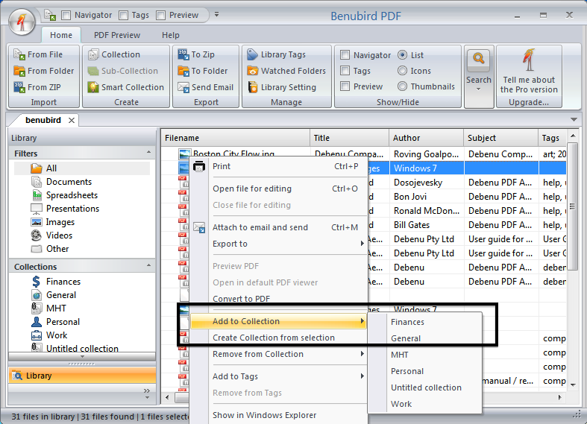

Figure 11 - Add files to collection

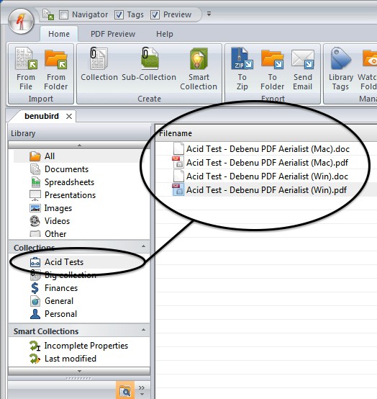

Figure 12 - Display collection

1. You can delete a collection by right clicking on it and selecting Delete from the context menu. Note that this will only delete the collection; the files that were contained within that collection still exist in the main Library and any other existing collections they belong to.

## Smart Collections

Smart Collections provide a rule-basis method of automatically creating and updating collections based on file properties.

1. To create a Smart Collection, select the Smart Collections button from the Create panel, which will open the Smart Collections dialog, where you can specify your rules.

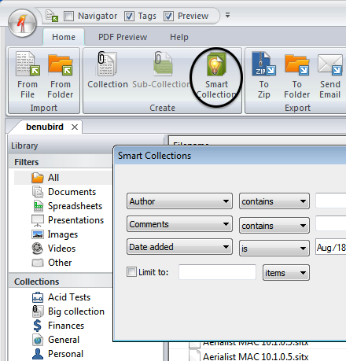

Figure 33–Create a Smart Collection

1. Using a Smart Collection you could automatically filter out all files that complied with a rule that you specified. For example, you could the following:

*Author* ***is*** *Stephen King* ***AND*** *Subject* ***contains*** *Horror* ***AND*** *File Type* ***is*** *.PDF*

Your new Smart Collection would only display files where the author is Stephen King, the Subject is Horror and the file format is PDF.

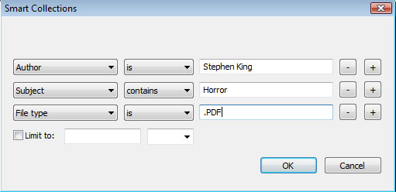

Figure 44 - Smart Collections dialog

## Navigator

The Navigator is the primary properties filter. Any properties that you add to files using the Get Info dialog will be displayed here.

1. To open the Navigator, select the checkbox that says ‘Navigator’ in the View panel.

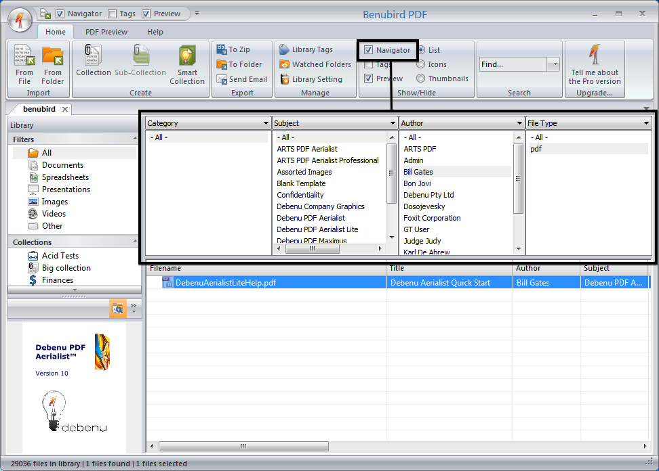

Figure 55–the Navigator

1. The Navigator allows you to quickly filter the file list based on available file properties such as Categories, Subject, Author, File Type, Day Created, Month Created, etc.

For example, by selecting a value in the Authors column, you are saying that you only want to see files where the author matches the value you’ve selected in the Authors column. You could then further filter the list of available files by choosing to filter additional values from other columns, such as Subject.

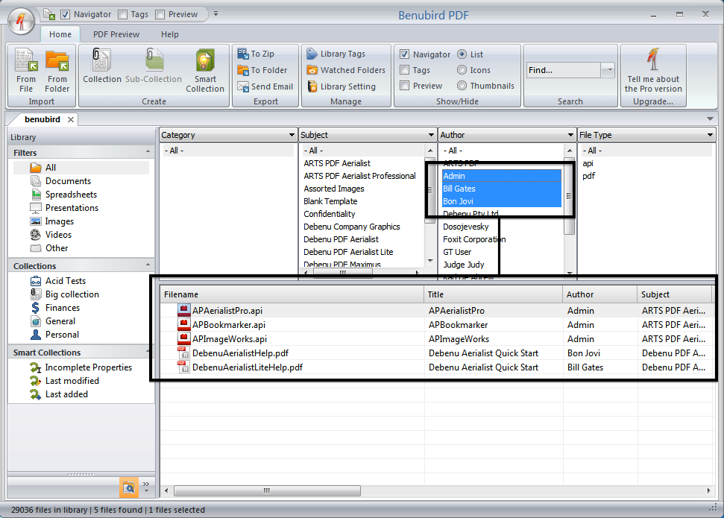

Figure 66 - filtering using the Navigator

1. You can choose multiple values from each of the columns, or you can simply leave ‘All’ selected for a column, if you do not wish to filter any values from that column.
2. Multiple values in a column can be selected by holding down Ctrl and left clicking.

## Tags

The Tags filter is the primary filter for tags. It offers perhaps the fastest route to pinpointing the exact file or group of files that you want.

1. To open the Tags filter, select the checkbox that says ‘Tags’ in the View panel.

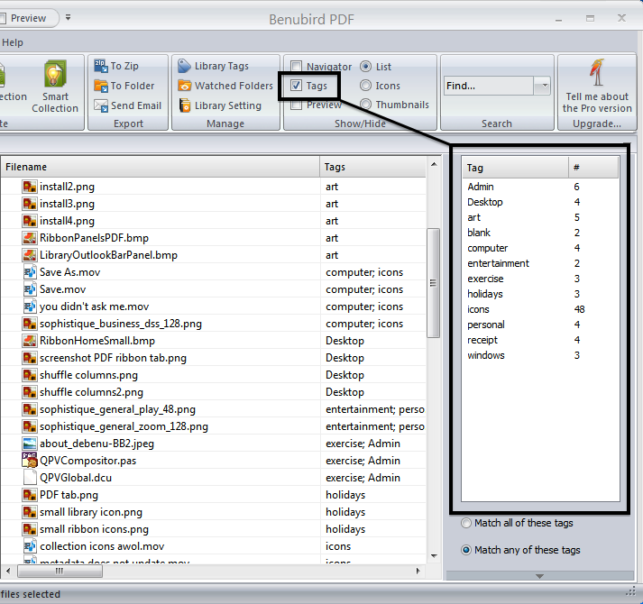

Figure 77 - the Tags filter

1. The Tags filter allows you to quickly filter the file list based on the tags that each file contains. All tags that are associated with files are shown in the Tags filter and the number of times each tag has been used is also displayed.
2. If you select a tag in the Tags filter the file list is updated so that it only displays files that contain the selected tag.

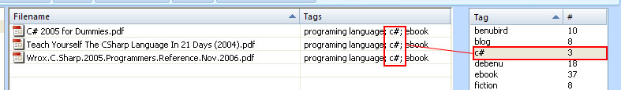

Figure 8 - Filtering using a single tag

1. You can filter using one or multiple tags. If you have the “Match all of these tags” checkbox selected in the Tags filter then only files that contain all of the selected tags will be displayed, but if you have the “Match any of these tags” checkbox selected then any files that contain one or more of the selected tags, will be displayed.

In this example “Match all of these tags” is selected. As you can see, only files that contain all of the selected tags are displayed.

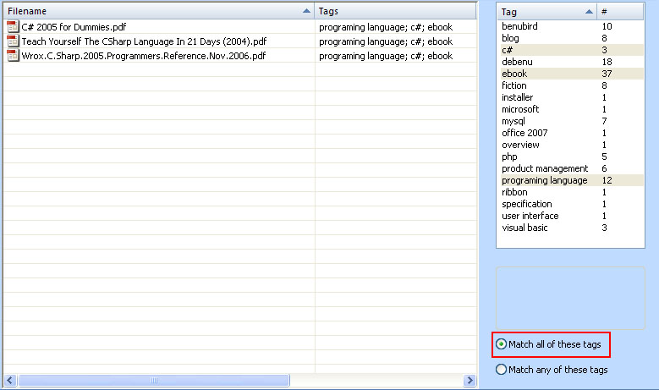

Figure 9 - Match all of these tags

In this example “Match any of these tags” is selected. As you can see, any file that contains one or more of the selected tags is displayed.

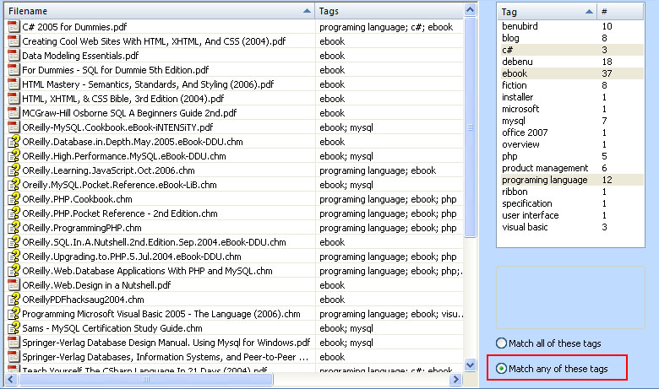

Figure 20 - Match any of these tags

## Repository mode

Benubird can be used to with an internal repository rather than directly linking to files. This was the primary method but has been changed by request from users.

When you use this feature, each time you “Add” a file to Benubird, it will be copied into Benubird’s internal archive.

To activate Repository mode:

1. Open the Library Settings dialog; select the “Use Repository” checkbox.

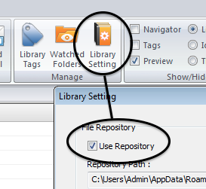

1. Benubird will now copy files to the Benubird Repository as you add them.
2. All functions that you perform within Benubird will now operate on these files rather than any external sources.
3. Open a file by double-clicking or selecting “Open to Workspace” from the Ribbon. It will then be opened in a temporary area called Workspace.

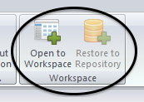

1. All updates will occur here.
2. When you have completed your edits, select the “Restore to Repository”. You will be prompted to either save the change or discard. If you choose discard then all edits will be ignored, else the updated file will save over the original copy in the repository.